

**Computer Networks Lab 6**



**Name:Muhammad Shaheer.**

**Roll No:20p-0480**

NATIONAL UNIVERSTIY OF COMPUTER AND EMERGING SCIENCES, FAST- PESHAWAR CAMPUS Department of Computer Science & Software Engineering

Tasks:

1. Configure an email server in Packet Tracer.

**1. Build the network topology**

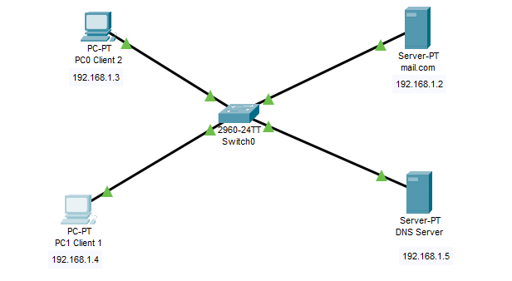

**2. Configure IP addresses on the PCs, DNS Server and the Mail Server**

• Mail.com Server IP address: 192.168.1.2

• PC0 Client 2 IP address: 192.168.1.3

• PC1 Client 1 IP address: 192.168.1.4

• DNS server IP address: 192.168.1.5

**3.** So let’s configure a DNS server.

Click DNS server, click **Services** tab, then pick **DNS**. Turn the service **ON.** Set name-address pairs and  add them to the server. You can view the DNS entry below:

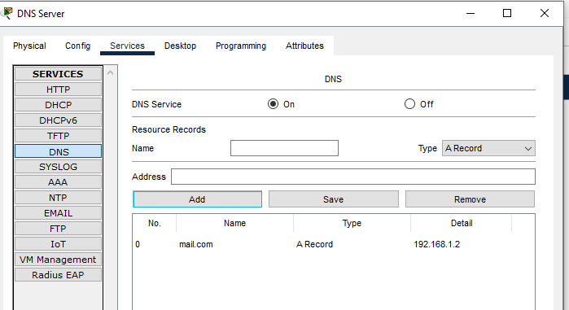

**Mail Server:**

Next, we’ll configure the **email server.**

To do this, click on the server, then click **Services** tab, pick **email** server from the menu.

Provide the **Domain name** of the server then click on **Set** to set it. In this example I’ve used the name  ‘mail.com’ .

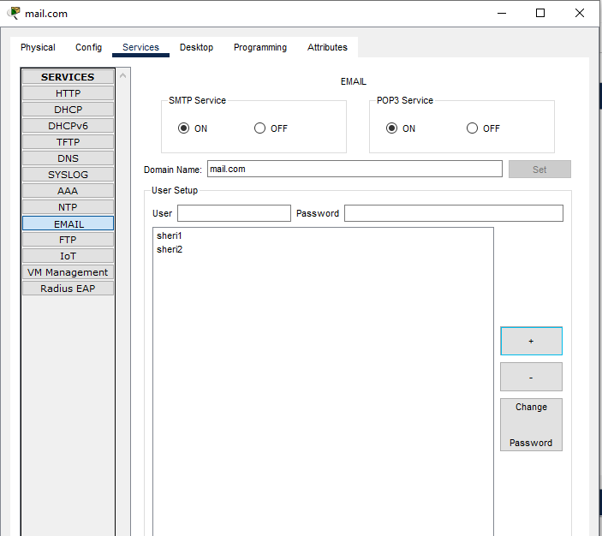

For Client 1: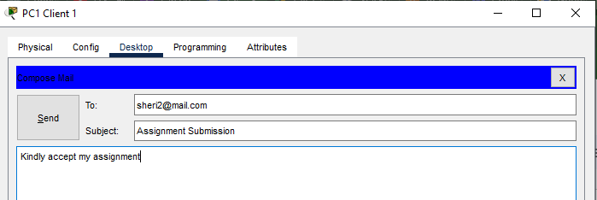

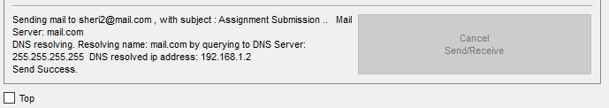

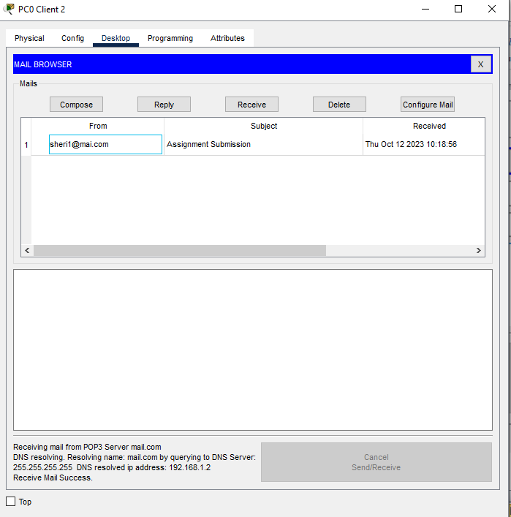

For Client 2:

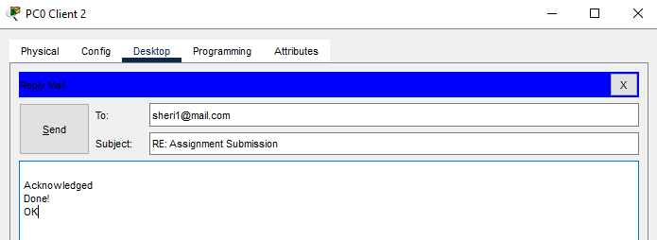

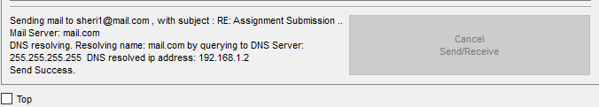

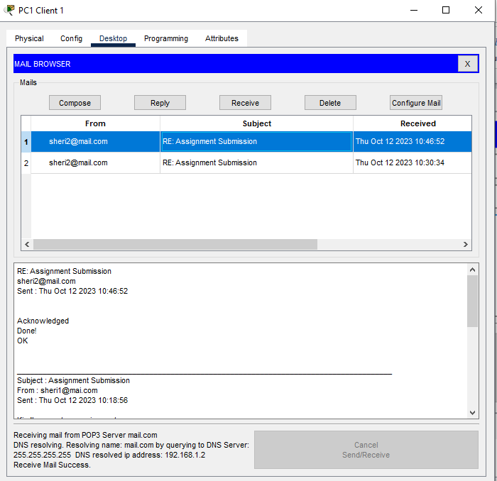

2. Being a Network Engineer you get a project to design network of a company named  as **MasterTech**. Your client has two routers (directly connected with each other) and three  switches. There are three departments in his office i.e Backend Department, Frontend  Department, and Management. Your client wants to avoid static IP’s  configurations. Your client requirement is to host his website on a server,  URL: **(www.mastertech.com)**. Your client also wants email services in the network,  email domain is “**mt.com**”. Design, label and configure the network topology in Cisco  Packet tracer.

**1. Build the network topology**

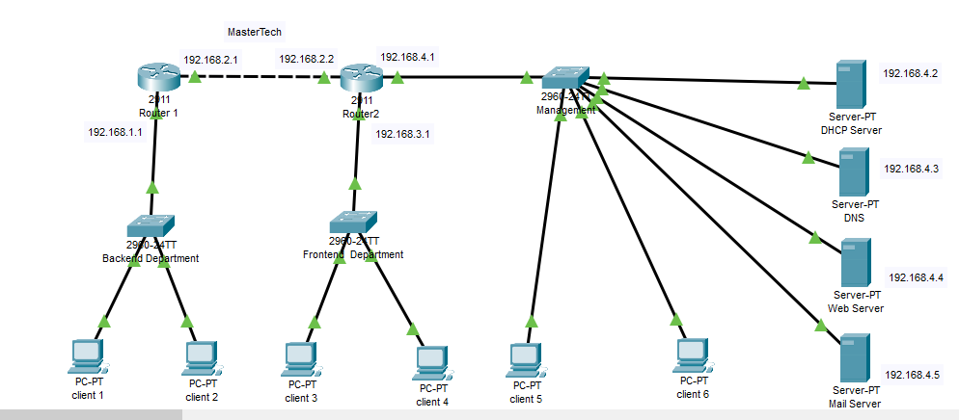

Now Router Configuration:

For Router 1:

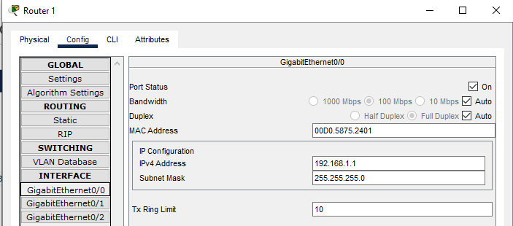

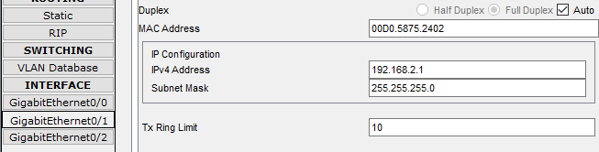

For Router 2:

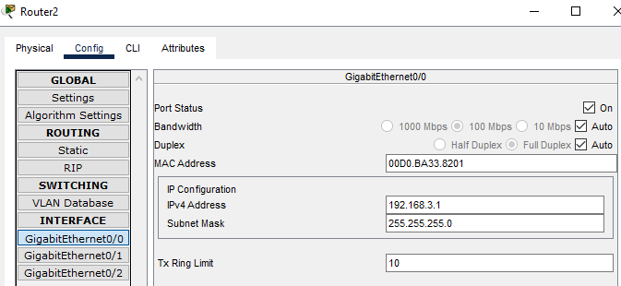

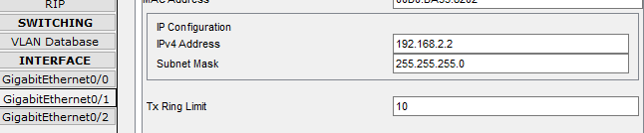

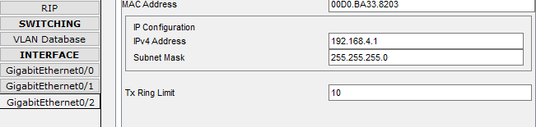

For DHCP configuration:

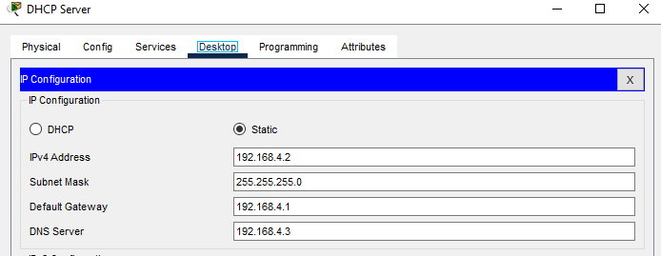

Making Pools:

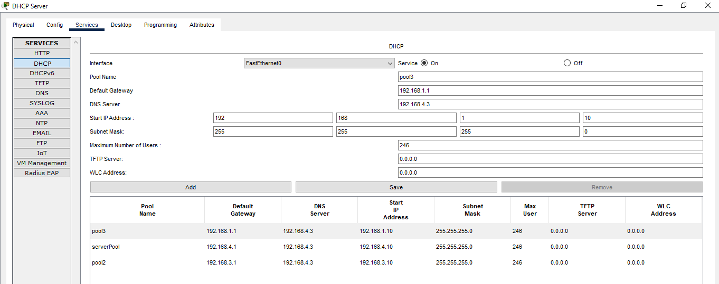

Now check DHCP Request:

For PC7:

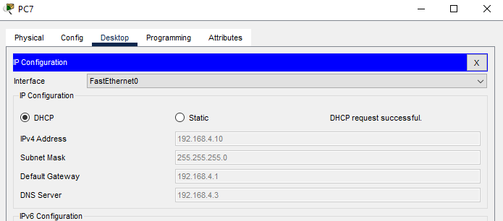

For PC 6:

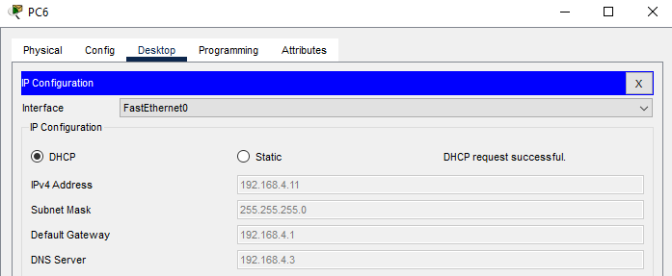

Use helper ID for Router 2:

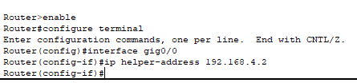

Now

For PC 4:

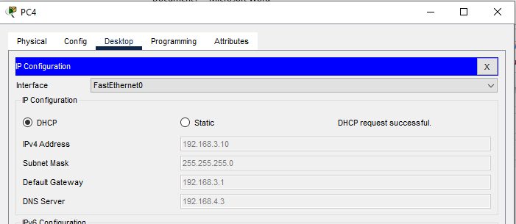

For PC 5:

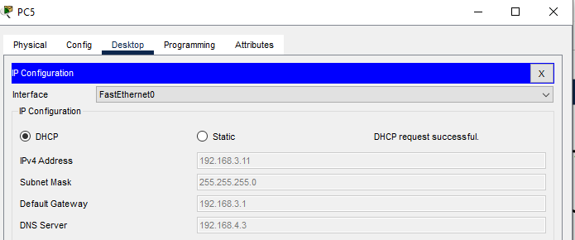

Use helper Id for Router 1:

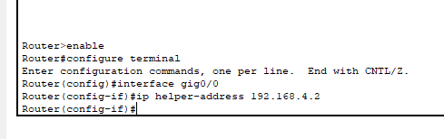

For PC:2

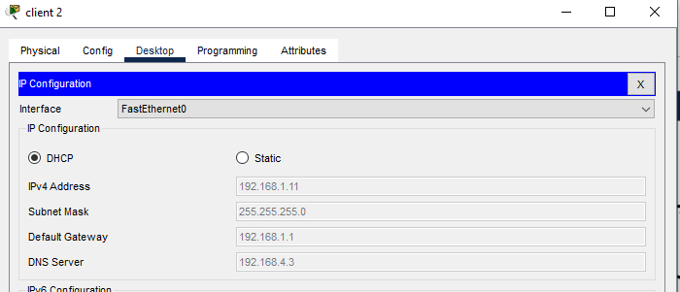

For PC 1:

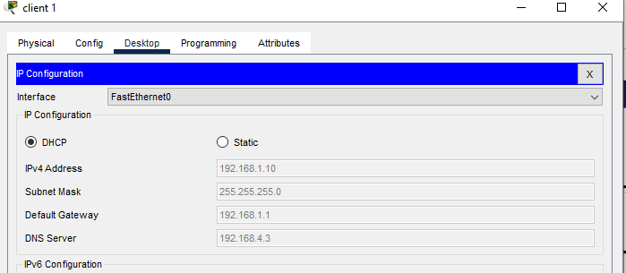

Now For website configuaration:

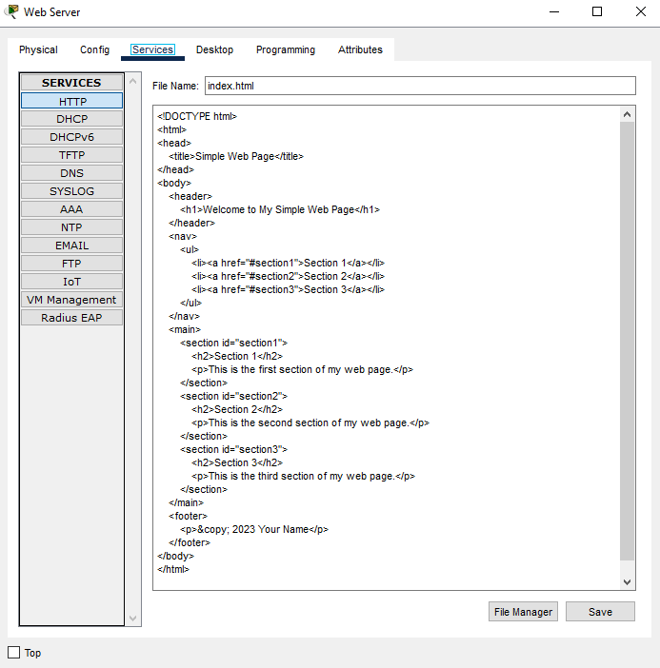

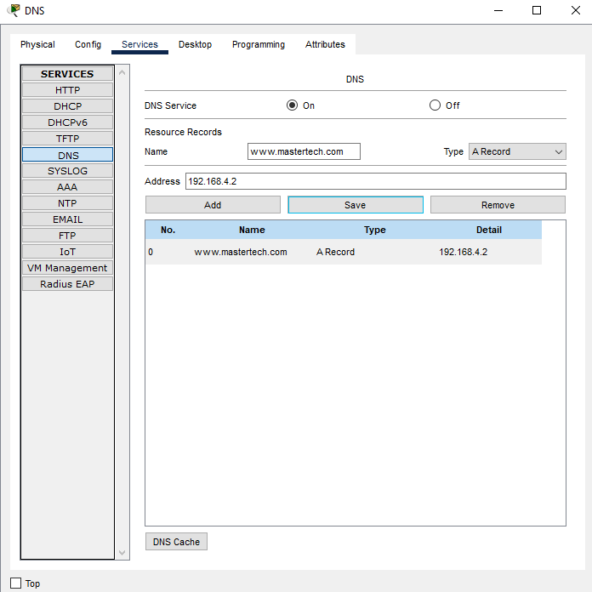

Output:

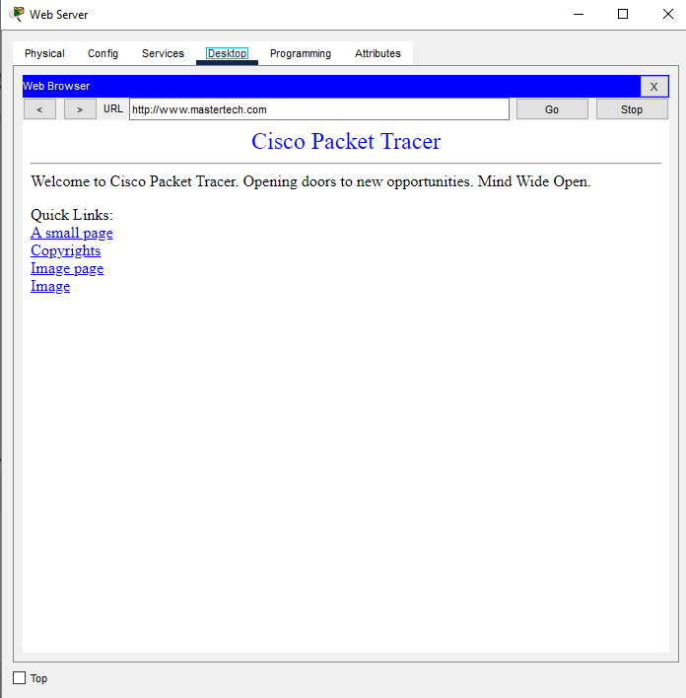

Now

Email services:

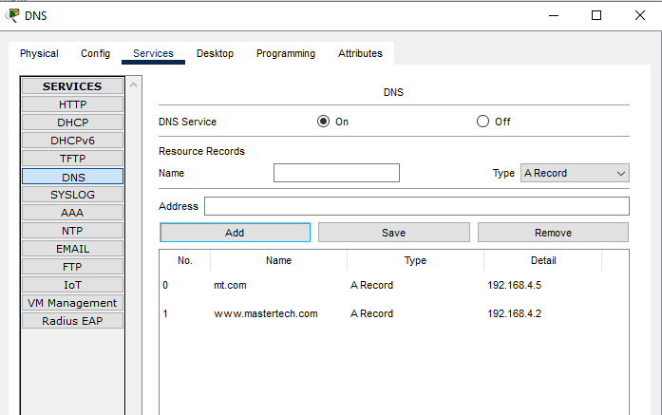

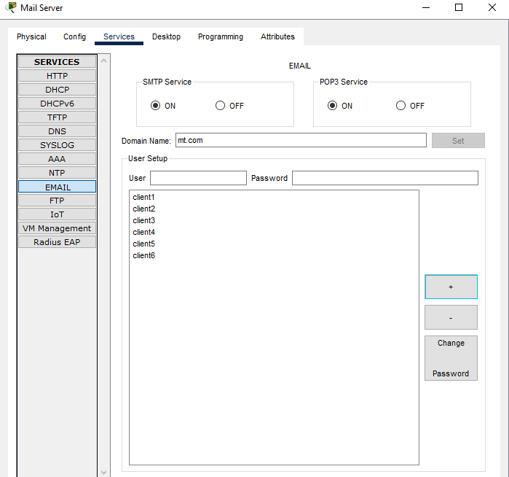

For PC 6:

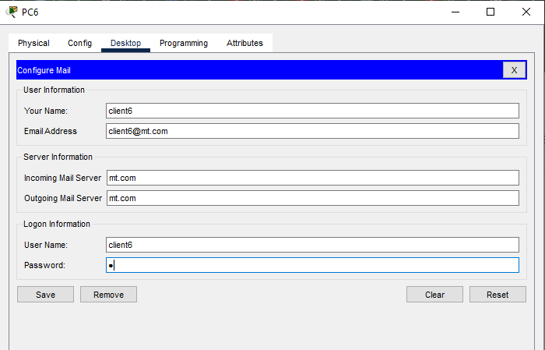

For PC 5:

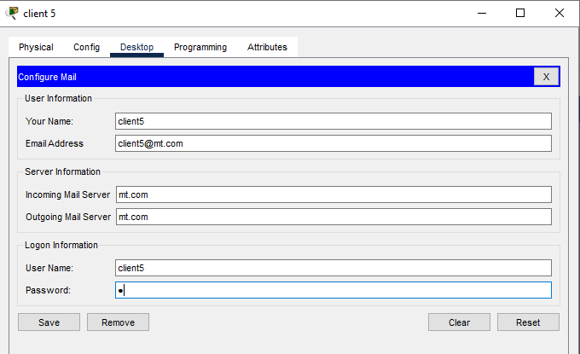

For pc4:

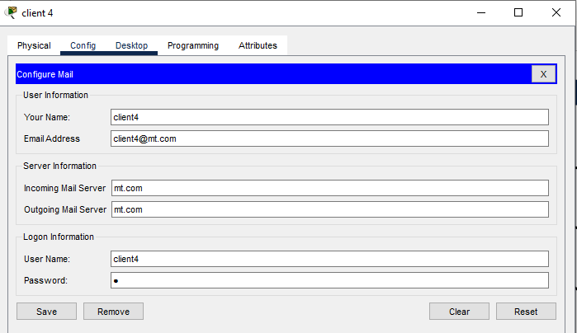

For pc 3:

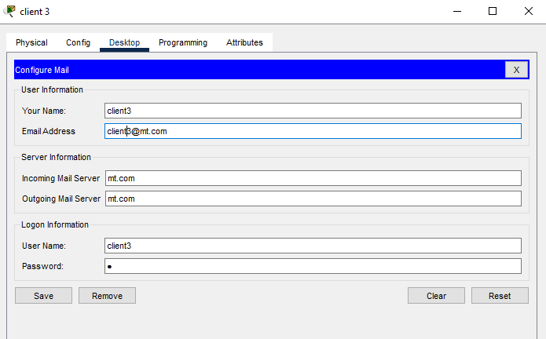

For PC 2:

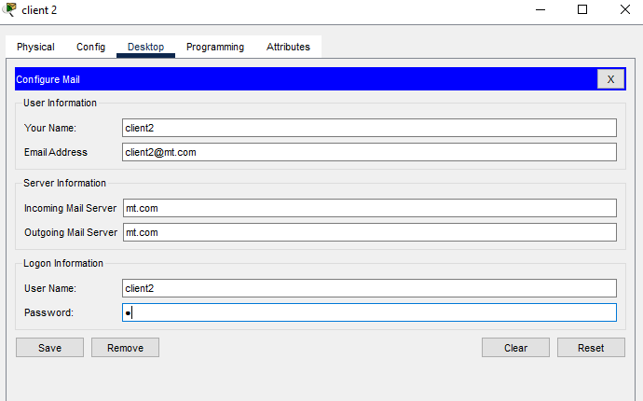

For pc1:

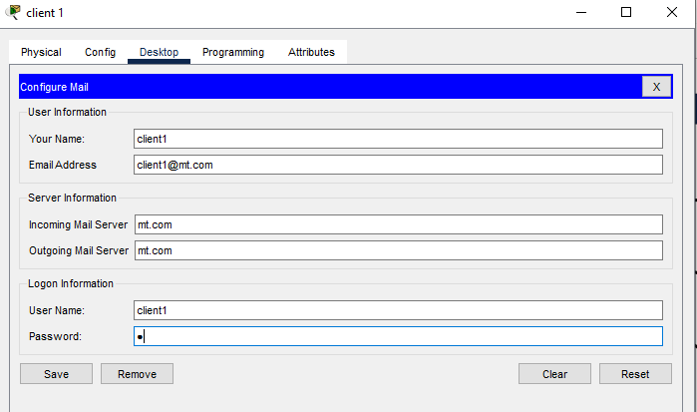

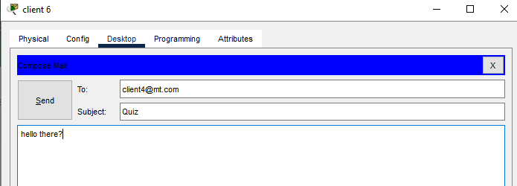

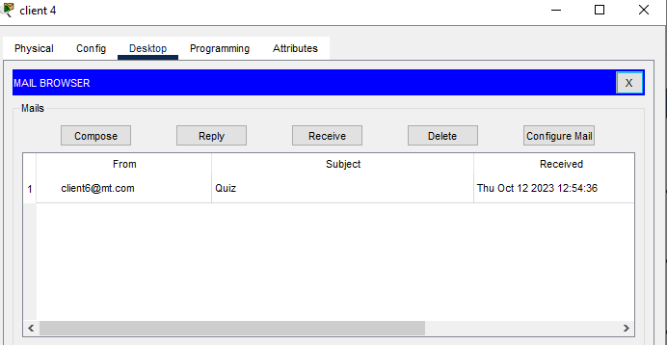

Hence mail receved successfully and all devices are connected.